Economic Development and Poverty Reduction Analysis using ETL Processes

1. **Krutarth Majmundar**
2. **Darshan Sardar**
3. **Nilka Patel**
4. **Maharshi Joshi**

# Table of Contents

**Introduction** **3**

**Literature Review** **6**

Enhanced Methodological Insights 6

Deeper Dive into Key Factors 7

Synthesizing Study Outputs for a Holistic Understanding 7

Project Relevance and Conclusion 8

**Data Set** **9**

Overview of Data Collection 9

Attributes, Format, and Size 9

Exploratory Data Analysis (EDA) 14

Significance in the Context of the Study 14

**Methodology** **14**

Data Gathering 15

Strategic Approach to Data Sourcing 15

Criteria for Data Selection 16

Overcoming Data Gathering Challenges 16

Data Cleaning and Pre Processing 17

Handling Missing Data 17

Standardizing Data Formats 17

Normalizing Data for Comparative Analysis 18

Identifying and Correcting Outliers 18

Ensuring Data Consistency and Integrity 18

Automation and Scalability 19

Python's Role in Initial Data Cleansing 19

Automation and Efficiency 20

Ensuring Data Quality 20

Talend Open Studio's Contribution to Data Integration 20

Complex Data Workflows 21

Enhancing Data Integrity 21

Learning and Adapting 21

Data Analysis and Visualization 24

Power BI's Capabilities: 24

Python's EDA Role: 25

Methodological Choices 25

Alternatives and Justifications 25

**Results** **26**

Trend Analysis 26

Correlation Analysis 26

Comparative Analysis During Crises 28

Unemployment Rate and Poverty Rate Correlation 30

Insights and Implications 31

Panel Data Analysis 32

Visualization Insights 32

Policy Implications and Recommendations 33

Strengthening Economic Resilience through Foreign Reserves Accumulation: 34

Addressing Unemployment with Quality Job Creation: 34

Utilizing Data-Driven Approaches for Policy Formulation: 35

Encouraging Multisectoral Collaboration: 35

Conclusion of Results 36

**Discussion and Conclusion** **36**

Significance of the Findings 37

Summary of Work 37

Conclusion 38

**Bibliography** **39**

Code Libraries and Software 39

**References** **40**

# 

# Introduction

In an era where data-driven decision-making has become paramount, the study of economic development and poverty reduction stands at the forefront of global challenges. This project represents a concerted effort to explore the nuanced dynamics between economic growth and its implications for poverty alleviation. By embarking on this research, we aim to contribute to the critical discourse on how economic policies can be optimized to benefit all sections of society, particularly the most vulnerable. Our journey through this investigation has been marked by rigorous data collection, comprehensive literature review, meticulous data preprocessing, sophisticated Extract, Transform, Load (ETL) processes, advanced exploratory data analysis (EDA), and innovative visualization techniques.

The inception of this project was guided by a clear recognition of the complexities inherent in understanding the multifaceted relationship between economic development and poverty. With this awareness, our initial step involved an extensive search and curation of datasets that span a wide range of economic indicators. This phase was not merely about data accumulation but about selecting information that could provide a holistic view of the economic landscape and its interconnections with poverty levels across various geographies and temporal scales.

Building upon a solid foundation of relevant data, we ventured into an exhaustive literature review. This process was instrumental in embedding our research within the existing body of knowledge, drawing upon contemporary studies, historical data analyses, and theoretical frameworks that have shaped the understanding of economic development and poverty reduction strategies. The literature review served a dual purpose: it informed our analytical approach and highlighted gaps in the current research, thereby positioning our study as a bridge between past insights and future explorations.

Transitioning from theoretical exploration to practical application, we engaged in the critical task of data preprocessing. This stage was characterized by a meticulous examination and cleaning of the datasets, ensuring their reliability and relevance for the subsequent ETL processes. Employing the Transcend application alongside Power BI, we harnessed powerful ETL techniques to transform raw data into structured, analyzable formats. This phase was pivotal in optimizing the data for analysis, removing inconsistencies, and standardizing formats across disparate sources, thereby laying a robust groundwork for in-depth examination.

With the data refined and ready, we delved into the exploratory data analysis (EDA) phase using Python. This step was marked by a thorough investigation of the datasets, employing statistical models and data visualization libraries to uncover initial insights, trends, and patterns. Finally, our findings were synthesized and brought to life through comprehensive visualization in Power BI. This stage transformed complex data sets into accessible, intuitive visual narratives, enabling stakeholders to grasp the nuances of economic development and its impact on poverty reduction. Through dynamic dashboards and detailed reports, we presented our analysis in a format that fosters engagement, encourages exploration, and facilitates informed decision-making.

In the following sections, this report will delve into a comprehensive literature review, shedding light on prior research and situating our study within the broader academic discourse. We will then detail the methodologies employed in data preprocessing and analysis, providing insights into the ETL processes and exploratory data analysis techniques that underpin our findings. The results of our analysis will be presented through a series of Power BI visualizations, offering a nuanced understanding of the data. Finally, we will discuss the implications of our findings for economic policy and poverty reduction strategies, culminating in a set of evidence-based recommendations for policymakers and stakeholders. Appendices and a bibliography will provide additional resources and references that support our research.

# Literature Review

The intricate relationship between economic development and poverty reduction has long been a focal point of academic and policy discourse. In an era where data-driven decision-making has become paramount, the utilization of Extract, Transform, Load (ETL) processes to analyze extensive data sets represents a significant advancement in this field. This expanded literature review builds upon previous insights, drawing from a diverse array of studies to explore the multifaceted dynamics of economic growth, employment, policy efficacy, and their roles in alleviating poverty.

## Enhanced Methodological Insights

The studies under review employ a variety of methodological approaches, reflecting the complexity of the phenomena they investigate. From Diao et al.'s (2005) spatially disaggregated models that highlight the sector-specific pathways to poverty reduction, to the econometric and comparative analyses by Balisacan, Pernia, & Estrada, and Dursun & Ogunleye, which underscore the critical role of employment quality and policy frameworks. These methodologies not only facilitate a deeper understanding of the economic-poverty nexus but also underscore the value of ETL processes in managing and analyzing the underlying data.

## Deeper Dive into Key Factors

A closer examination of the literature reveals several key factors influencing poverty reduction:

* **Sectoral Growth and Employment**: The agricultural sector's impact on rural poverty alleviation (Kadir & Amalia, 2016; Diao et al., 2005) and the importance of employment quality in West African countries (Dursun & Ogunleye) highlight the need for growth strategies that prioritize labor-intensive sectors and decent job creation.
* **Policy Interventions and Income Redistribution**: The transformative role of social policies in Brazil (Ferreira, Leite, & Ravallion) and the nuanced discussion on income versus non-income poverty indicators by Klasen illustrate the critical importance of targeted policy interventions and the broader dimensions of poverty.
* **Measurement Challenges**: Klasen's exploration of measurement issues emphasizes the complexities of accurately capturing the impacts of economic growth and policy interventions on poverty, advocating for a multidimensional approach to poverty assessment.

## Synthesizing Study Outputs for a Holistic Understanding

The synthesis of findings from the reviewed studies paints a complex picture of the economic growth-poverty reduction nexus. It becomes evident that:

* Economic growth is a necessary but not sufficient condition for poverty reduction, with the distribution of growth gains playing a crucial role.
* Sector-specific strategies, particularly those focusing on agriculture and labor-intensive industries, are vital for translating economic growth into widespread poverty alleviation.
* The effectiveness of policy interventions, especially those aimed at income redistribution and social welfare, is paramount in ensuring that the benefits of growth are equitably shared.
* A comprehensive approach to measuring poverty, incorporating both income and non-income indicators, is essential for accurately assessing progress and informing policy.

## Project Relevance and Conclusion

The expanded insights from this literature review underscore the complexity of addressing poverty through economic development strategies. For our project, leveraging ETL processes to integrate and analyze diverse datasets emerges as a critical approach. This enables not only the examination of economic indicators and sectoral contributions but also the assessment of policy impacts and regional disparities. By adopting a data-driven, comprehensive analysis framework, our project is well-positioned to contribute valuable insights into effective strategies for promoting economic development and reducing poverty. The synthesis of diverse data sources and methodologies, as reflected in the literature, will guide the formulation of inclusive, evidence-based economic policies and interventions, marking a significant step forward in the ongoing efforts to alleviate poverty.

# Data Set

## Overview of Data Collection

Our project employs a comprehensive array of data, meticulously collected and curated from reputed international sources like the World Bank and the International Monetary Fund (IMF). This data encompasses a wide spectrum of economic indicators, such as GDP growth, Consumer Price Index (CPI), unemployment rates, and poverty rates, over an extensive period from 1960 to 2022.

| **Dataset Name** | **Description** | **Period Covered** | **Geographical Coverage** | **Relevance to Project** |
| --- | --- | --- | --- | --- |
| **GDP Deflator Annual 2022** | Measures the ratio of GDP in current local currency to GDP in constant local currency, indicating inflation. | 2022 | Global | Provides insight into the inflation-adjusted growth of economies. |
| **Official Exchange Rate 2022** | Official exchange rates for various currencies compared to the USD. | 2022 | Global | Reflects the economic stability and international competitiveness of countries. |
| **Retail Sales Volume Index 2022** | Tracks changes in the volume of sales at retail outlets, excluding inflation effects. | 2022 | Global | Indicates consumer spending and economic health. |
| **Terms of Trade Annual 2022** | Ratio of the index of export prices to the index of import prices. | 2022 | Global | Shows the relative changes in export vs. import prices over time. |
| **Total Reserves Annual 2022** | The total reserves held by a country's central bank in foreign currencies. | 2022 | Global | Indicates a country's ability to manage currency stability and economic shocks. |
| **CPI Annual 2022** | Consumer Price Index showing changes in the price level of a basket of consumer goods and services. | 2022 | Global | Measures inflation and cost of living. |
| **GDP Growth Annual 1960-2022** | Annual percentage growth rate of GDP at market prices based on constant local currency. | 1960-2022 | Global | Indicates the economic growth rate over time. |
| **GDP Market Prices Current & Constant 2022** | GDP at current and constant prices in the national currency and USD for comparing real and nominal growth rates. | 2022 | Global | Differentiates between nominal growth and real growth adjusting for inflation. |
| **Poverty Rates OECD 2022** | Measures the percentage of the population living below the national poverty line. | 2022 | OECD Countries | Directly relates to the project's focus on poverty reduction. |
| **Unemployment Rate Annual 2022** | The percentage of the labor force that is jobless and seeking employment. | 2022 | Global | Indicates economic health and labor market conditions. |
| **Exchange Rates Real & Nominal 2022** | Real and nominal exchange rates against the USD, adjusted for inflation. | 2022 | Global | Assesses currency value in real terms, influencing trade and investment. |
| **Foreign Reserves Annual 2022** | Total foreign exchange reserves, including gold and foreign currencies. | 2022 | Global | Reflects economic resilience and monetary policy capability. |
| **Industrial Production Annual 2022** | Measures the output of the industrial sector, including manufacturing, mining, and utilities. | 2022 | Global | Indicates industrial capacity and economic productivity. |
| **Stock Market Indices 2022** | Performance of national stock market indices, reflecting investor sentiment and economic trends. | 2022 | Global | Gauges financial market health and economic confidence. |
| **Trade Data Imports & Exports 2022** | Value of imports and exports, providing a trade balance overview. | 2022 | Global | Shows trade dynamics, affecting GDP and economic stability. |
| **Economy Metadata 2022** | Contains metadata for economies, including income classifications and regions. | 2022 | Global | Provides context for analyzing economic data within specific income and regional classifications. |
| **Country Dimension** | Contains unique identifiers and names for countries. |  | Global | Facilitates country-specific analysis and integration of different datasets by providing a unique country code. |
| **Dimension** | Contains years with unique identifiers, facilitating time-series analysis. | 1960-2024 | - | Supports temporal analysis across datasets by assigning a unique time code to each year. |
| **Fact Table** | Consolidated table containing key economic indicators linked to Country and Time dimensions. | 1960-2024 | Global | Central table where the analysis is based, integrating multiple indicators with geographic and temporal codes. |

Table 1 : Dataset with description along with other variable

# Methodology

Our project aimed to analyze economic development and poverty reduction using various datasets spanning from 1960 to 2022. The methodology encompassed several stages, from data gathering and cleaning to analysis and visualization, employing a mix of tools including Python, Talend Open Studio, and Power BI.

## Data Gathering

The data gathering process for our analysis was meticulous and multifaceted, designed to source the most accurate and comprehensive data available for economic development and poverty reduction across a wide array of countries and years. Given the complex nature of economic data, which spans various indicators such as GDP growth, unemployment rates, and poverty rates, among others, it was crucial to identify sources that not only provided extensive coverage across different geographies and timeframes but also upheld the highest standards of data integrity and reliability.

### Strategic Approach to Data Sourcing

Our strategy for data sourcing was twofold: First, we focused on global financial institutions known for their rigorous data collection methodologies, such as the World Bank, the International Monetary Fund (IMF), and the Organisation for Economic Co-operation and Development (OECD). These organizations are renowned for their comprehensive databases on global economic indicators, offering a wealth of data that is crucial for a study of this scope and scale.

### Criteria for Data Selection

To ensure the relevance and reliability of the data collected, we applied a stringent set of criteria for data selection:

* Credibility: Preference was given to sources with a proven track record of accuracy and reliability in their data reporting.
* Comprehensiveness: We sought datasets that offered a broad overview of economic indicators over extended periods, enabling longitudinal analyses.
* Consistency: The data needed to be consistent in terms of the metrics and methodologies used for data collection across different countries and years, facilitating comparability.
* Relevance: Every dataset was evaluated for its direct relevance to the themes of economic development and poverty reduction, ensuring that our analysis remained focused and pertinent to our research objectives.

## Data Cleaning and Pre Processing

The Data Cleaning and Preprocessing stage was a critical component of our project, essential for transforming the raw data into a structured format amenable to analysis. This process involved several steps, each designed to address different aspects of data quality and consistency.

### Handling Missing Data

One of the first challenges we faced was dealing with missing values across the datasets. Missing data can introduce significant bias and make analysis unreliable. To address this, we employed multiple imputation techniques for less critical fields, ensuring the integrity of our datasets without discarding valuable information. For key economic indicators, we opted for a more cautious approach, using interpolation methods to estimate missing values based on trends within the dataset, thereby preserving the chronological integrity of our time series data.

### Standardizing Data Formats

Disparities in data formats, especially when dealing with a global dataset that includes multiple countries and regions, can complicate analysis. Our preprocessing efforts included standardizing data formats, particularly for dates and numerical values. This involved converting all dates to a uniform format and ensuring that all numerical values were in a consistent unit of measurement, facilitating seamless integration and comparison across datasets.

### Normalizing Data for Comparative Analysis

Given the wide range of economic indicators covered in our project, normalizing data was crucial for enabling comparative analysis. This step was particularly important for indicators like GDP growth and unemployment rates, where raw values could be misleading without considering the economic context of each country. We normalized these indicators against relevant benchmarks, such as per capita values or as percentages of GDP, to allow for meaningful comparisons across different economies and time periods.

### Identifying and Correcting Outliers

Outliers can significantly skew analysis, leading to misleading conclusions. Through visual inspection and statistical tests, we identified outliers in our datasets. In some cases, these outliers were legitimate reflections of economic events, such as recessions or sudden growth spurts, and were retained for analysis. In other instances, outliers resulted from data entry errors or anomalies in reporting standards. These were corrected where possible, or otherwise documented and excluded from analysis to ensure the reliability of our findings.

### Python's Role in Initial Data Cleansing

Python's pivotal role began with the initial phase of data cleansing. The choice of Python was informed by its robust ecosystem, which includes pandas for data manipulation, NumPy for numerical analysis, and Matplotlib and Seaborn for data visualization. These libraries provided us with a comprehensive toolkit for identifying and addressing various data quality issues, such as missing values, inconsistencies, and outliers.

### Talend Open Studio's Contribution to Data Integration

Transitioning from Python, Talend Open Studio was instrumental in the next phase of our data journey—ETL (Extract, Transform, Load). Talend's graphical interface and drag-and-drop functionality made it accessible to team members with varying levels of technical expertise, while its powerful components enabled the handling of complex data transformation and integration tasks.

One of Talend's key strengths is its ability to manage complex data workflows efficiently. Through its components, we designed ETL jobs that transformed the cleansed data from Python into a format ready for analysis and visualization. This included merging datasets from multiple sources, transforming data to a consistent format, and loading it into our analytical tools.

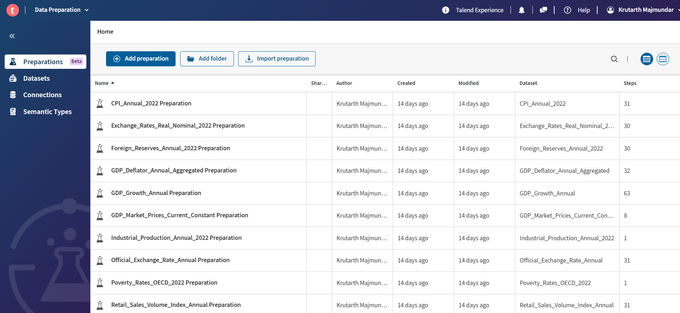

Figure 1 : Screenshot of the Data Preparation interface in Talend Open Studio showing various data preparations listed with details like the name, author, and date modified.

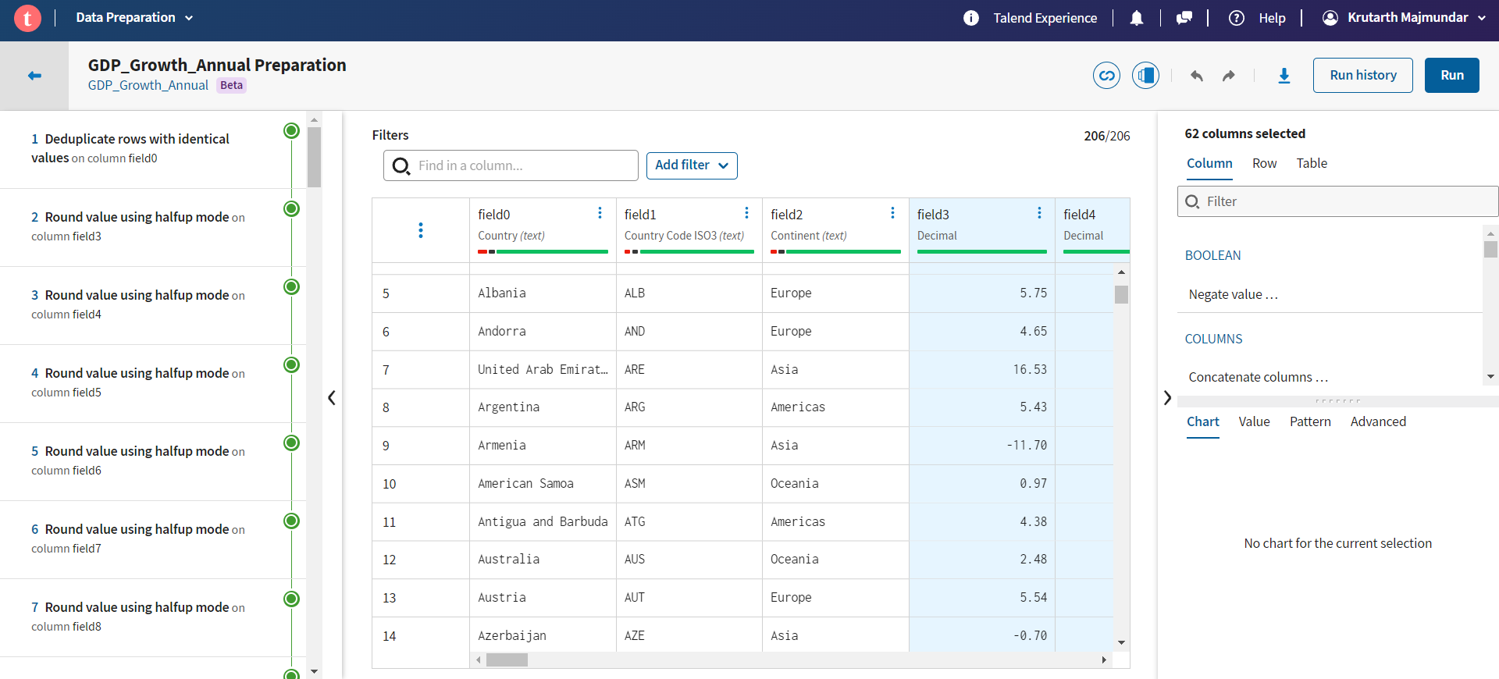

Figure 2: Detailed view within the Data Preparation of the GDP Growth Annual preparation, showcasing steps taken for data cleaning and manipulation.

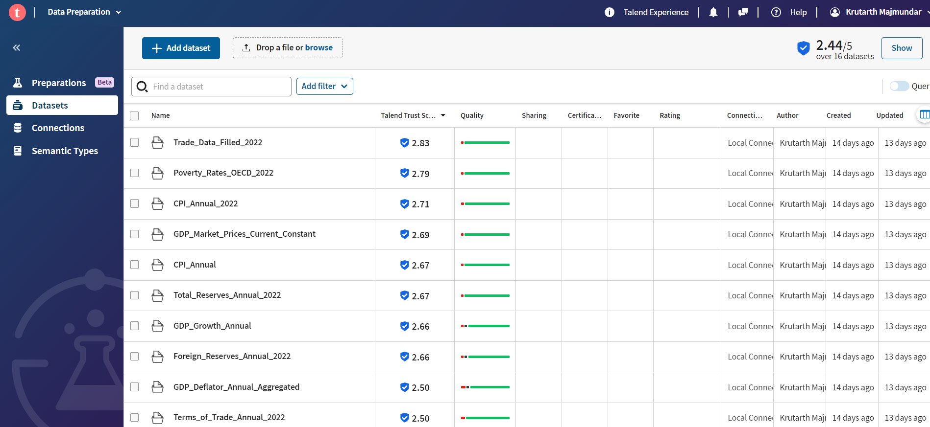

Figure 3: Overview of datasets available in Talend Open Studio's Data Preparation module, highlighting data quality scores.

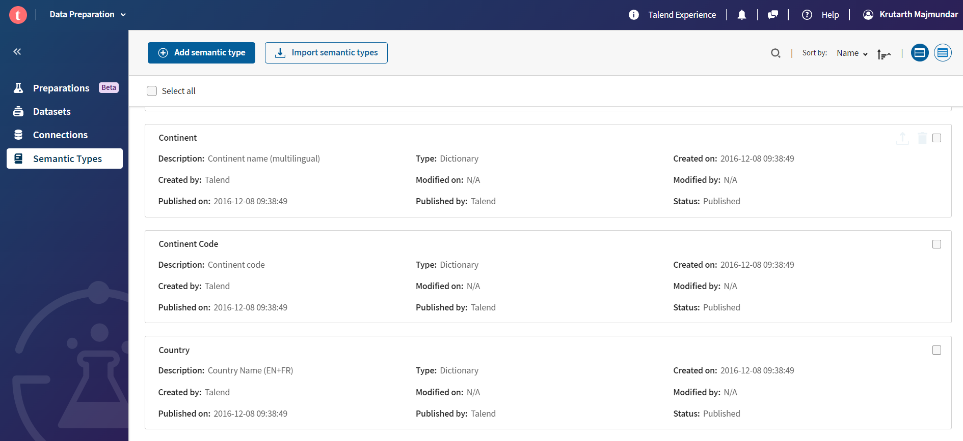

Figure 4: A snapshot of the semantic types interface in Talend Open Studio, which is used for categorizing data columns semantically.

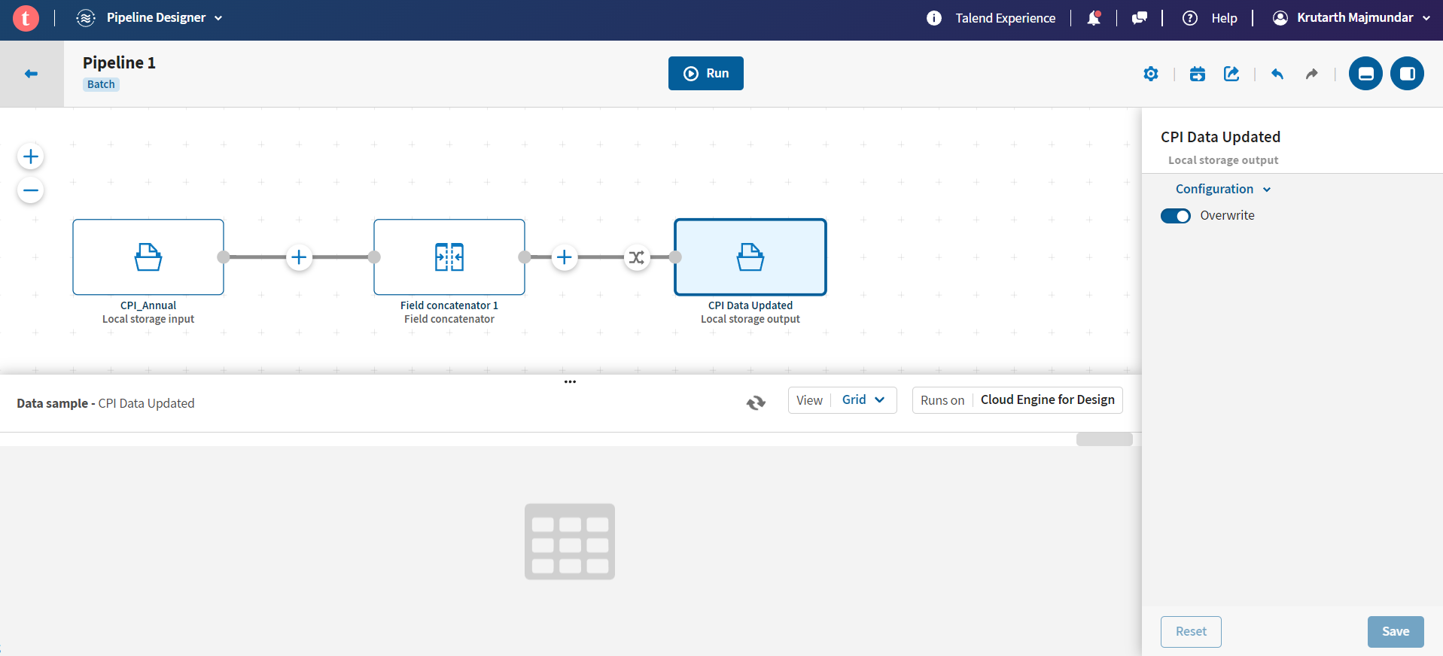

Figure 5: Visualization of a data integration pipeline in Talend Open Studio, depicting a process flow from input through transformation to output.

## Data Analysis and Visualization

With a clean and structured dataset in hand, we turned our focus to the analysis and visualization phase. Power BI emerged as our tool of choice for this task, offering a blend of powerful analytics capabilities with intuitive visualization options.

### Power BI's Capabilities:

The choice of Power BI was driven by its ability to handle large datasets and its flexibility in creating interactive dashboards. Our analyses were brought to life through a variety of visualizations, from trend lines charting economic growth to comparative bar charts highlighting poverty reduction efforts across regions. Power BI's dynamic filtering and slicing features enabled us to tailor our analyses to specific questions and scenarios, providing rich, contextual insights.

#### Global Events Impact Analysis Dashboard:

This dashboard vividly illustrates the fluctuations in economic indicators during key global events such as the Covid-19 pandemic and previous economic crises. The interactive elements like year selectors suggest it's designed for a dynamic analysis. The first graph showcases the average GDP growth by year, with a notable dip during the pandemic years. The second graph displays the average unemployment rate, which saw significant spikes correlating with the crises. At the bottom, a scatter plot juxtaposes GDP growth against unemployment rates before and after these events, with individual data points possibly representing different countries or years, hinting at the inverse relationship typically observed between these two metrics.

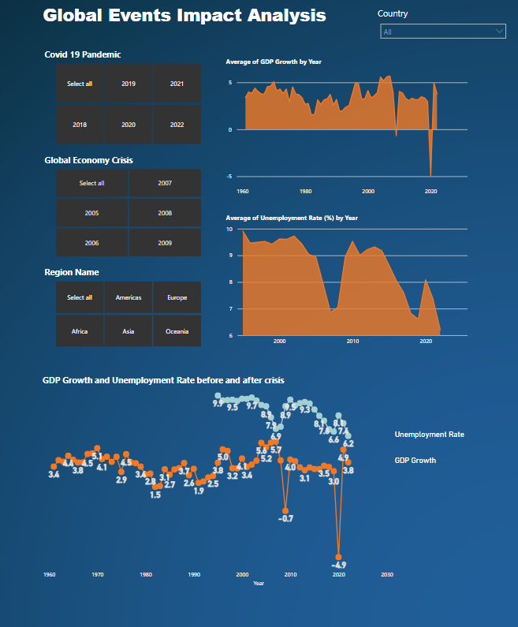

Figure 6: First one page of Power Bi Interactive Dashboard showcasing Global Events Impact Analysis

#### Dynamics of Economic Shifts & Social Impact Dashboard:

This dashboard takes a broader view, integrating social and economic variables such as foreign reserves, consumer price index, unemployment, poverty rates, and stock market indices. The color-coded map points to the global reach of the data, with interactive features allowing users to explore by country. The line graph comparing foreign reserves and consumer price index highlights the volatility and trends over two decades. The bar graph correlates unemployment and poverty by region, suggesting a direct relationship between these indicators. The stock market indices by ISO country code provide a snapshot of economic performance, pivotal for investors and policymakers alike.

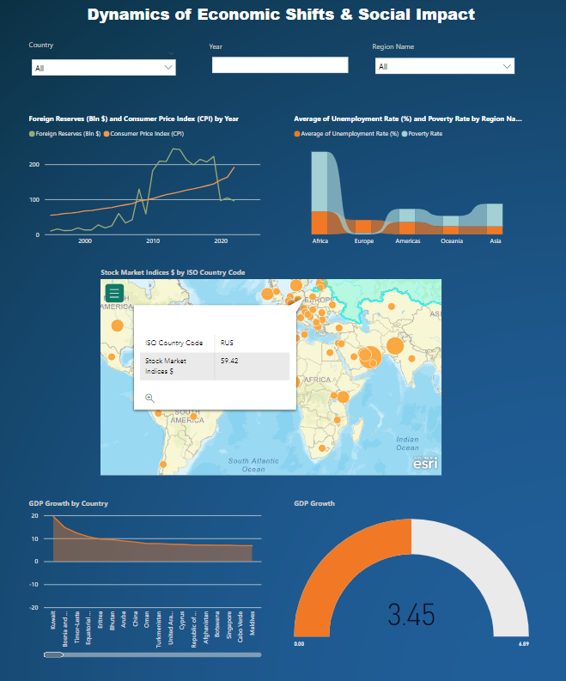

Figure 7: Second page of Power Bi Interactive Dashboard showcasing Dynamics of Economic Shifts & Social Impact

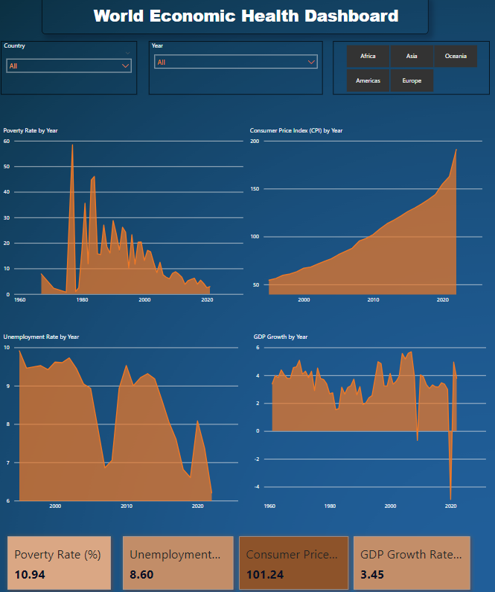

Figure 8: Third page of Power Bi Interactive Dashboard showcasing World Economic Health Dashboard

#### World Economic Health Dashboard:

The final dashboard presents a more straightforward design focused on long-term trends in economic health through indicators such as poverty rate, consumer price index, unemployment rate, and GDP growth. The consistent use of a single color theme and large, bold graphics makes the data easily digestible. The sharp spikes in the poverty rate graph, alongside a steadily rising consumer price index, paint a picture of increasing cost of living challenges. The fluctuation in unemployment rates and GDP growth across the decades reflects the resilience and vulnerability of the global economy to various shocks. The dashboard encapsulates these complex phenomena in a format that is accessible for both experts and laypersons.

### Python's EDA Role:

Complementing our visual analysis, Python's statistical libraries facilitated an in-depth EDA, enabling us to explore correlations, trends, and patterns in the data. This dual approach ensured a comprehensive exploration of our datasets, grounding our visual findings in statistical rigor.

# Results

## Trend Analysis

The exploration of economic trends revealed significant fluctuations in GDP growth, shedding light on the cyclical nature of global economies. The analysis, visually supported by the "GDP Growth Over Time" graph, indicated pronounced downturns during global economic crises, with a notable contraction observed during the 2020 COVID-19 pandemic. This period starkly contrasts with times of economic expansion, particularly highlighted by robust growth in the early 2000s and the recovery phase following the 2008 financial crisis.

Unemployment trends, while varying across different geographic regions, did not display a uniform global trajectory, suggesting that local economic policies and conditions heavily influence labor market outcomes. Despite this variability in unemployment trends, a general decline in poverty rates over the last few decades was identified, indicating a positive shift toward global economic improvement. The "Poverty Rate Over Time" graph provided a clear visual confirmation of this downward trend, illustrating the gradual but steady progress in poverty reduction efforts globally.

## Correlation Analysis

The correlation heatmap offered insightful revelations into the interrelationships among various economic indicators:

GDP Growth and Unemployment Rate: The slight negative correlation (−0.13) between these two indicators suggests a weak inverse relationship. This finding implies that an increase in GDP growth is marginally associated with a decrease in unemployment rates, though the relationship is not strong enough to suggest a direct causality.

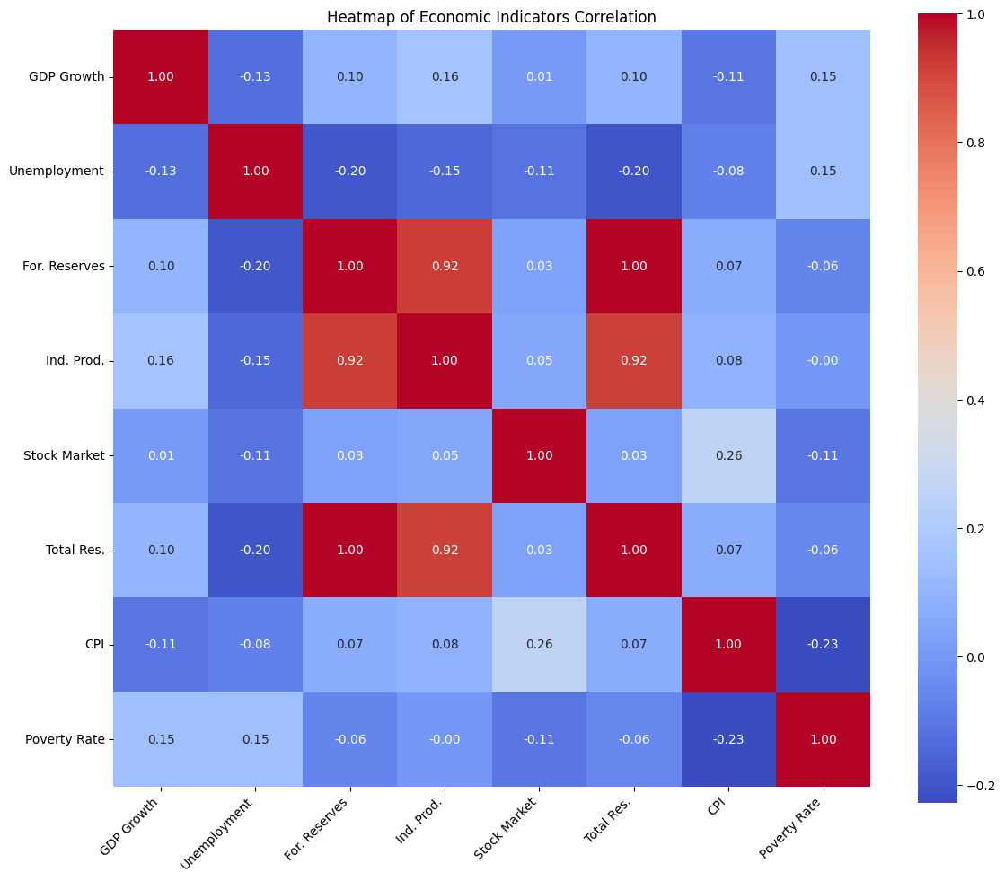

Figure 7: Correlation Matrix of all the factors

Foreign Reserves and Industrial Production: A robust positive correlation (0.92) was observed here, indicating that countries with substantial industrial production tend to amass higher foreign reserves. This relationship underscores the importance of a strong industrial base in bolstering economic resilience and capacity to accumulate foreign reserves.

CPI and Poverty Rate: The moderate negative correlation (−0.23) between the Consumer Price Index and poverty rates suggests that higher costs of living, potentially indicative of stronger economies, are associated with lower levels of poverty. This correlation may reflect the dual aspects of economic development where increased living costs in more developed economies come with improved social safety nets and higher overall wealth, contributing to poverty reduction.

## Comparative Analysis During Crises

The economic resilience of nations during the financial turmoil of 2008 and the unprecedented COVID-19 pandemic in 2020 was a focal point of our analysis. A key finding from this examination was the differential impact of these crises on countries based on their foreign reserves. Countries categorized with high foreign reserves experienced a notably less severe economic downturn, evidenced by an average GDP Growth of 1.66% during crisis periods. In contrast, nations with lower foreign reserves recorded a modest average GDP Growth of 1.09%. This analysis, supported by the "GDP Growth and Foreign Reserves During Crises" visualization, underscores the protective role that substantial foreign reserves play in buffering economies against external economic shock.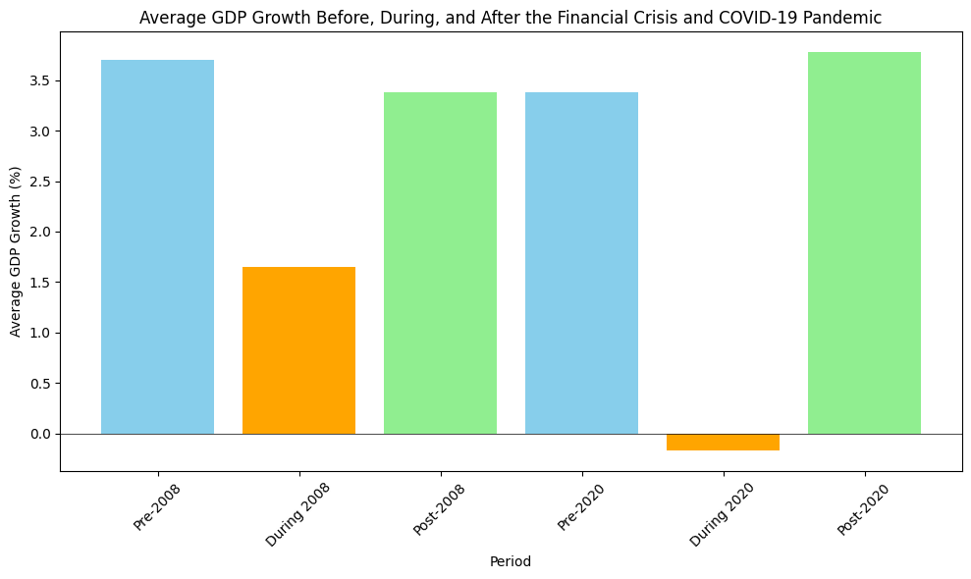

Figure 8: Bar Chart of GDP Growth over 2008 and 2020 crisis

This comparative analysis reveals the strategic importance of foreign reserves in economic crisis management, highlighting how nations with more substantial reserves are better positioned to weather global economic downturns. The visualization provides a stark depiction of this dynamic, offering a clear visual representation of the correlation between foreign reserve levels and GDP growth resilience during periods of economic stress.

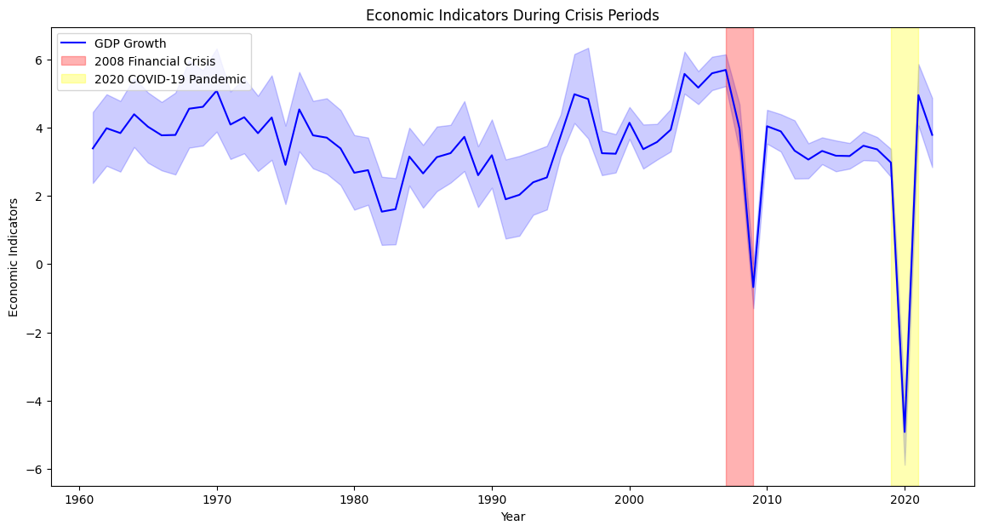

Figure 9: Line Graph of GDP Growth from 1960 to 2023

## Unemployment Rate and Poverty Rate Correlation

Further analysis explored the relationship between unemployment rates and subsequent poverty rates. The calculation of a correlation coefficient of 0.133 revealed a slight but positive association between the two variables. This correlation suggests that increases in unemployment rates could marginally elevate poverty rates in the following year. This finding is critical, as it indicates that while unemployment is a factor in poverty elevation, its impact is not overwhelmingly strong, pointing to the existence of other significant factors influencing poverty rates.

## Insights and Implications

The analyses conducted offer valuable insights into the multifaceted relationship between economic indicators and poverty reduction. The correlation analysis, in particular, sheds light on the interconnectedness of economic development factors, emphasizing the complexity of poverty reduction efforts. The comparative analysis during crises highlights the importance of economic resilience and the protective role of foreign reserves, suggesting policy implications for economic management and crisis preparedness.

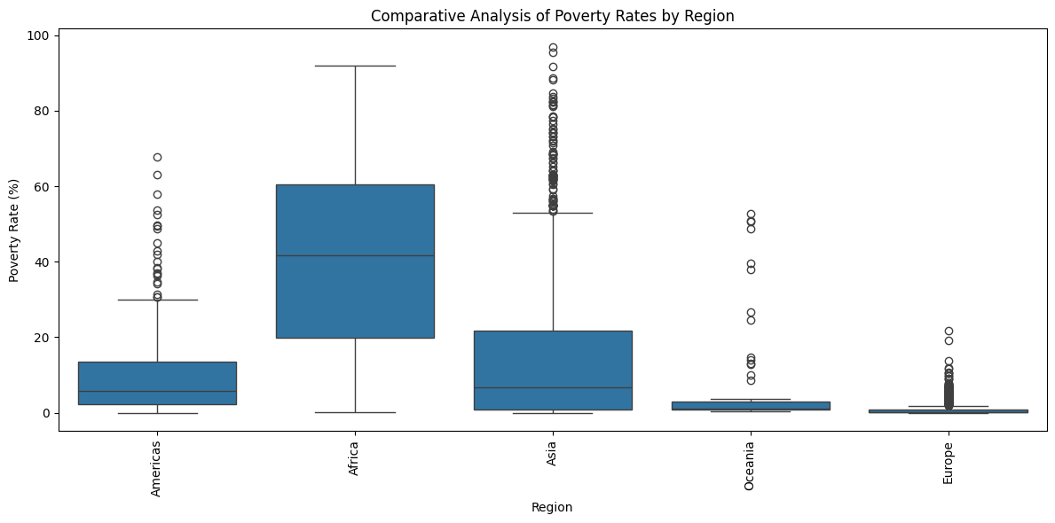

Figure 10: Box Plot of Poverty Rates over different regions

## Visualization Insights

The suite of visualizations developed throughout the analysis played a pivotal role in elucidating the complex relationships between economic development indicators and poverty reduction. From trend graphs depicting the cyclical nature of GDP growth and the general decline in poverty rates, to the correlation heatmap revealing intricate associations among economic metrics, each visual element contributed to a comprehensive understanding of the factors influencing poverty.

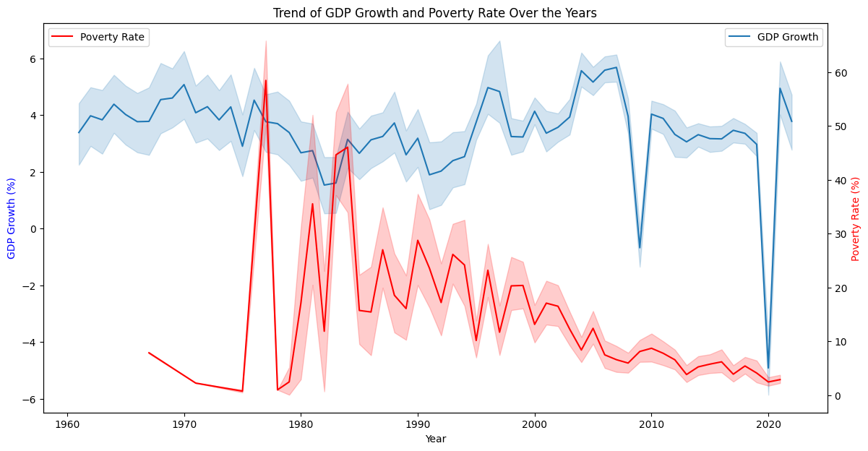

Figure 11: Line chart includes GDP Growth and Poverty over all years

The "GDP Growth Over Time" graph highlighted the economic volatility associated with global crises, while the "Poverty Rate Over Time" graph provided a visual testament to the gradual improvements in poverty reduction over the decades. The "Correlation Heatmap" offered a snapshot of how interconnected economic indicators are, fostering a deeper appreciation for the multifaceted nature of economic development and its impact on poverty.

## Policy Implications and Recommendations

The findings from our detailed analyses offer a wealth of insights that can guide policymakers in crafting strategies aimed at economic development and poverty alleviation. Here are several key implications and actionable recommendations based on the research:

### Strengthening Economic Resilience through Foreign Reserves Accumulation:

The demonstrated importance of foreign reserves in buffering economies against crises underscores the need for policies that prioritize reserve accumulation. Governments could consider measures to enhance their trade balances, encourage foreign investment, and manage external debt to bolster reserve levels.

### Addressing Unemployment with Quality Job Creation:

The slight correlation between unemployment rates and subsequent poverty rates highlights the importance of not just creating jobs, but ensuring these are quality jobs that offer decent wages and job security. Policies might include investing in skills training, strengthening labor laws to protect workers, and incentivizing industries that offer sustainable employment opportunities.

### Utilizing Data-Driven Approaches for Policy Formulation:

The use of comprehensive data analyses, as exemplified by this research, should be a cornerstone of policy formulation. By employing evidence-based approaches, policymakers can better understand the complex dynamics at play and devise strategies that are tailored to their specific economic and social contexts.

### Encouraging Multisectoral Collaboration:

Economic development and poverty reduction are multifaceted challenges that require coordinated efforts across different sectors. Governments, the private sector, civil society, and international organizations should collaborate closely, leveraging their unique strengths and resources to address the root causes of poverty.

## Conclusion of Results

The analyses underscore the complex interplay between economic growth, stability, and poverty reduction. The significant role of foreign reserves in buffering economies against crisis emerged as a key theme, suggesting that robust reserve accumulation can serve as a critical strategy for enhancing economic resilience. Furthermore, the nuanced relationship between unemployment and poverty rates highlighted the limitations of using single indicators to gauge economic health or predict poverty trends.

Overall, the results from this comprehensive analysis offer valuable insights for policymakers, economists, and development practitioners seeking to understand the levers of poverty reduction and the prerequisites for sustainable economic development. By leveraging a multifaceted analytical approach, encompassing trend analysis, correlation studies, comparative crisis impact assessment, and the exploration of panel data dynamics, we gain a richer understanding of how to effectively combat poverty in the context of global economic fluctuations.

# Discussion and Conclusion

The outcomes of our project, "Economic Development and Poverty Reduction Analysis," illuminate the intricate dynamics between various economic indicators and their impacts on poverty rates across different countries and time periods. The insights derived from our extensive data analysis underscore the pivotal role of GDP growth, unemployment rates, and consumer price indices in shaping economic development and strategies for poverty alleviation.

## Significance of the Findings

* GDP Growth as an Economic Barometer: Our findings reaffirm GDP growth as a crucial determinant of economic health, directly correlating with improvements in living standards and reductions in poverty levels. This highlights the necessity for policies aimed at stimulating economic growth as a pathway to poverty reduction.
* Unemployment Rate's Impact on Poverty: The analysis sheds light on the significant impact of unemployment rates on poverty, illustrating how job creation and workforce development are critical for lifting populations out of poverty. It suggests a focus on sectors that can generate sustainable employment opportunities.
* Inflation's Dual Edged Sword: The role of consumer price indices in influencing the purchasing power of the population is another critical finding. While moderate inflation can indicate a healthy economy, excessive inflation can erode real incomes, exacerbating poverty. This underscores the importance of balanced monetary policies.

## Conclusion

The significance of our results extends beyond academic inquiry; it offers practical guidance for policymakers, economists, and development practitioners. By identifying the levers of economic growth and the pitfalls of unemployment and inflation, our project provides a data-driven blueprint for addressing poverty. The analysis underscores the need for targeted economic policies that stimulate growth, promote job creation, and control inflation, paving the way for sustainable poverty reduction. As we conclude, it's clear that our journey through data has unearthed insights critical for shaping a more prosperous, equitable world.

# Bibliography

## Code Libraries and Software

* Python Libraries:
  + Pandas: For data manipulation and analysis. <https://pandas.pydata.org/>
  + NumPy: For numerical computing. <https://numpy.org/>
  + Matplotlib: For creating static, interactive, and animated visualizations. <https://matplotlib.org/>
  + Seaborn: For statistical data visualization. <https://seaborn.pydata.org/>
* ETL Tool:
  + Talend Open Studio: Used for data integration and cleansing processes. <https://www.talend.com/products/talend-open-studio/>
* Data Visualization:
  + Power BI: Microsoft Power BI for creating interactive dashboards and reports. <https://powerbi.microsoft.com/>
* Software and Online Resources
  + Adobe Photoshop: Used for creating and editing visual content for the project poster. <https://www.adobe.com/products/photoshop.html>
  + Staples Printing Services: For printing the project poster. <https://www.staplescopyandprint.ca/>
* Data Sources
  + World Bank Open Data: Provided datasets on GDP, unemployment, CPI, and more for global economies. <https://data.worldbank.org/>
  + OECD Statistics: Offered datasets on poverty rates and economic indicators for OECD countries. <https://stats.oecd.org/>

# References

1. Balisacan, A. M., Pernia, E. M., & Estrada, G. E. B. (2003). Economic growth and poverty reduction in Viet Nam. In E. M. Pernia & A. B. Deolalikar (Eds.), Poverty, Growth and Institutions in Developing Asia (pp. 273–296). London: Palgrave Macmillan.
2. Casse, T., & Jensen, S. (2009). Do we understand the linkages between economic growth, poverty targets and poverty reduction? Review of Development Economics, 13(3), 539-553.
3. Diao, X., et al. (2005). Spatially disaggregated economy-wide models for policy analysis. World Development, 33(10), 1677-1693.
4. Dursun, G., & Ogunleye, B. (2016). Economic growth, employment and poverty reduction: The case of West African countries. American Journal of Economics, 6(1), 50-60.
5. Ferreira, F. H. G., Leite, P. G., & Ravallion, M. (2007). Poverty Reduction without Economic Growth? Explaining Brazil's Poverty Dynamics, 1985-2004. World Bank Policy Research Working Paper No. 4431.
6. Kadir, K., & Amalia, R. R. (2016). Economic growth and poverty reduction: The role of the agricultural sector in rural Indonesia. In Proceedings of the ICAS VII Seventh International Conference on Agricultural Statistics (pp. 1-10). Rome.
7. Klasen, S. (2008). Economic growth and poverty reduction: Measurement issues using income and non-income indicators. World Development, 36(3), 420-445.
8. Klasen, S. (2005). Economic growth and poverty reduction: Measurement and policy issues. OECD Development Centre Working Papers, No. 246. Paris: OECD Publishing.